**Brooklyn torah gazette**

**For parshas B0 5782**

Volume 6, Issue 16 (Whole Number 271) 6 Shevat 5782/ January 8, 2022

**Printed L’illuy nishmas Nechama bas R’ Noach, a”h**

For a free subscription, please forward your request to [***keren18@juno.com***](mailto:keren18@juno.com)

**The Danger of Following the**

**Akum in the Consumption of**

**Fancy Wines and Liquors**

**By Daniel Keren**

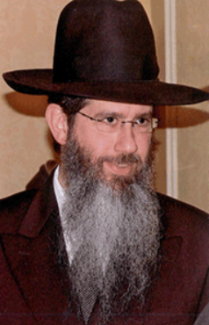

**Rabbi Dovid Goldwasser**

Rabbi Dovid Goldwasser, internationally renowned Maggid Shiur and Rav of Congregation Bnai Yitzchok in Flatbush spoke last month at a Hakhel Yarchei Kallah Event on the topic of “Halachich Perspectives for Our Times. He began by tackling the topic of wine and liquors at simchas and at the Shabbos table.

Rabbi Goldwasser declared that Klal Yisroel always has to be careful to avoid falling into the spiritual trap of following the ways of the akum (the non-Jewish) world which makes a big deal out of consuming fancy bottles of wine and liquors. This was highlighted by the teachings of the Spanish-born Rambam (Rabbi Moses ben Maimon, 1138-1204 (the personal physician of Saladin, the ruler of Egypt and one of the greatest Torah sages of all time) who commanded us to attach ourselves to Torah chachomim (scholars) and not follow the ways of the goyim.

**This Terrible Influence Unfortunately**

**Infects Our Own Community**

People (non-Jews) are accustomed to getting drunk, especially at this time of year, when they go from one party to another party. Unfortunately, Rabbi Goldwasser noted that this behavior drips down into our own community when people drink too much at a Kiddush or underage members of our community drink. We have a Torah obligation to obey the laws of the land which prohibit teenagers from drinking alcoholic beverages.

The Gemora (Talmud) warns that one who drinks too much is destined to become impoverished. One only needs to study in the Chumash (Parshas Noach) of the disgrace that befell an individual who before had been called by Hashem a tzaddik (righteous man) because of his drinking too much and thereby becoming drunk and acting inappropriately with very unfortunate consequences.

Rabbi Goldwasser recalled once when he was asked to serve as the mesader kedushin (the rabbi officiating a wedding) that one of two men called up to serve as eidim (witnesses) at the chuppah was quite inebriated. He had to tell the father of the chason (bridegroom) that he didn’t think this “gentleman” was up to the important job of serving as a witness.

**Is Such a Person Free of**

**Punishment from Shomayim**

One Jew to another, is there any obligation for an individual who is serving liquor whether to a patron in a restaurant or to a guest in one’s home or simch to verify whether or not that act would constitute a danger to not only the consumer of the alcohol but to others who might be confronting that drinker afterwards if he tries to drive a car? Even if the server of the alcoholic drink isn’t culpable by secular law courts, is he completely free from punishment from shomayim (the heavenly courts?)

Indeed, Rabbi Goldwasser declared that every Jew has to be responsible for the welfare of others who might be tempted to drink too much. One has an obligation to try to positively assist others to behave more appropriately and discourage reckless social drinking that is all too prevalent in the “society” around us today.

Switching to the topic of shidduchim (the Jewish system of matchmaking) it has become an all-too-common phenomenon for boys to insist on seeing the photos of prospective girls. Does the girl have to send these photos to the shadchan (the matchmaker) to share with potential boys?

Rabbi Goldwasser challenged those in the audiences if indeed this practice too is falling into following the ways of the goyim (with their dating service websites). For a Yid to be kosher, one must go against the trend that is popular in the general world surrounding us.

He quoted Pirkei Avos 3:7 where Rabbi Yaakov warned “One who walks on the road and studies (Torah) and interrupts his study and remarks, ‘How beautiful is this tree! How beautiful is this plowed field!’ Scripture considers it as if he were guilty of a mortal sin.”

**What Exactly Did He Do Wrong?**

Rabbi Goldwasser challenged the audience at the Hakhel Event with the questions: Why is this so? What exactly did he do wrong? Perhaps we can understand what bothers Rabbi Yaakov by figuring out what the “Torah scholar” travelling on the road should have said. Maybe, Rabbi Goldwasser suggests, the remarks should have focused on how nice are the leaves on this tree? Or how sweet are the fruits? Or some other similar aspects that would have highlighted the niflaos (wonders) HaBorei (of the Creator of the world). That would indeed be praiseworthy.

If one looks at a photo on a shidduch resume, Rabbi Goldwasser pondered, is it possible that one might not give the shidduch suggestion the proper consideration that it deserves. If instead of looking at the photo (which also might have been photo shopped into something that is not the reality) one would actually see the prospective match in person and by actually talking to the person, one will come away with a clearer perception and a better appreciation of that individual and their good qualities, that one will not be able to obtain from just merely looking at the photo. You can never, Rabbi Goldwasser emphasized get a true insight into the individual by glancing at the photo alone.

*Reprinted from the December 30, 2021 edition of the Flatbush Jewish Journal.*

**Rabbi Berel Wein**

**On Parshas Bo**

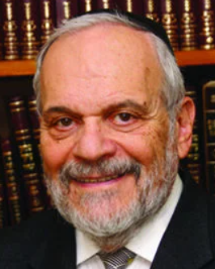

This week's Torah reading highlights the final contentious debate between Moshe and the Pharaoh of Egypt. The opening sentence that introduces the drama describes that Moshe should somehow come to Pharaoh and warn him of the consequences that the continuing oppression of the Jewish people will bring upon him and his nation.

The Hebrew text lends itself in the reading that Moshe should somehow come into Pharaoh, i.e., the name of the Parsha, "Bo". Moshe is supposed to get to Pharaoh's palace and gain some sort of understanding that will explain the stubbornness and masochism that dominates Pharaoh’s relationship with the Jewish people and his refusal to free them from subjugation and slavery.

What is undoubtedly perplexing is the adamant refusal by Pharoah to listen to the words of his own officers and advisors, who tell him that Egypt is lost. Yet despite everything - the plagues, the advice of his consultants and the imminent destruction of Egypt that Pharaoh is undoubtedly also aware of, he continues his suicidal course, and finds it impossible to save himself and his people from further tragedy. What drives Pharaoh to this extreme?

The Torah itself provides an answer, that the Lord has hardened the heart of the Pharaoh to such an extent that, no matter what blows will be visited upon him, and what the cost to Egypt will be, he will attempt to persevere and enforce this policy of enslavement over the Jews. Pharaoh has lost control of the situation, for Heaven is intervening and Pharoah's judgment is clouded.

Because of this circumstance, the hardening of the Pharaoh’s heart by Heaven, the moral question is raised by all the great commentators. If free will has been taken away from Pharaoh, then how can he be held accountable for his actions, and why should the Egyptian people be punished if they really have no choice but to pursue the cause of enslaving the Jewish people?

There have been many ideas advanced over the ages that deal with this logical, philosophical, and moral issue. It is clear the Torah informs us that there is a point of no return regarding the behavior of nations and individuals. Once that line is crossed, even though initially it is a matter of free will, there is no longer any way to avoid the consequences of their choice.

 It is analogous to missing the exit on a superhighway and finding that there is no other road that can lead them back to make the correct turn off the highway. The hardening of the heart of the Pharaoh recognizes the set of choices that he originally made in enslaving the Jewish people and refusing to listen to the words and warnings by others. Having made that choice in his own heart, he suffers the consequence of his behavior. He simply has ‘missed the exit’ and isn’t able to return to the correct path and direction.

*Reprinted from this week’s website of rabbiwein.com*

# Rav Avigdor Miller

# On Speaking English



**QUESTION:** **How is it that we permit ourselves in America to talk English?**

**ANSWER:** This question I waited for a long time already. Great kashe. Believe me, it’s a big kashe. I myself, at home, we never speak English. No. All my years, only Yiddish in my house.  That’s all.

When I was in Chaim Berlin, I never spoke English at all.  To the bochurim I spoke only Yiddish in Chaim Berlin.

But when I came to this neighborhood [Flatbush in Brooklyn], in this neighborhood I discovered a whole treasury of people who were Sefardim; they didn’t know any Yiddish.  Beautiful people!  Excellent people!  Once upon a time, at this Thursday night lecture it was all Sefardim.  That’s why I switched to English.

In general, if I’m invited to speak someplace, I don’t want to speak English. Anyplace else, only Yiddish.  But here because of my many good friends, the Sefardim, and some baalei teshuvas too who don’t know Yiddish, so I speak English.

But I’m telling you, it’s always libi nokfi – it bothers me very much. I would love it if I could speak Yiddish every week right here on Thursday night. But then I’d lose some of my good friends.  So, I can’t help it, that’s all.

But don’t learn from me.  Don’t learn from me!  שלא שינו את לשונם! Don’t change your loshon!

*Reprinted from the December 27, 2021 email of Toras Avigdor (Tape E-124)*

**Thoughts that Count**

**For Our Parsha**

*You will then be able to tell your children and grandchildren My miraculous signs that I have performed among them, and you will know that I am G-d.* (Exod. 10:2)

Since the Torah is telling us to relate the story of Egypt to our children and grandchildren, it should say, "and thus they will know I am G-d." When parents teach their children about G-d, their efforts carry a two-fold reward. They will merit to have children who have true faith in G-d. And, teaching and talking to their children about G-d will strengthen the parents' faith in G-d. *(Iturei Torah)*

*This month (Nissan) shall be for you the head of the months.* (Exod. 12:2)

"For you" seems superfluous. Nissan was and always will be month of miracles and redemption. By saying "for you" the Torah is emphasizing that the ultimate redemption -- the coming of Moshiach -- depends on you, the Torah study and good deeds of each every individual Jew. *(Iturei Torah)*

*And frontlets between your eyes.* (Exod. 13:16)

The two straps that hang from the head tefilin symbolize the flow of influence from the head to the rest of the body. The two straps are a continuation of the strap that surrounds the head, and begin to branch off from the special knot behind the head, which is the beginning of the spine. Just as the brain is the nerve center that controls the whole body, so too the intellect should vitalize and guide the entire life of a Jew. *(Sichot Kodesh, Cheshvan, 5718)*

*Reprinted from Reprinted from the 5757/1997 Bo edition of L’Chaim Weekly*

**Rejecting the Depravity of Egypt And Simultaneously Entering**

**The Eternal Covenant with G-d**

**From the Talks of the Lubavitcher Rebbe**

**Rabbi Menachem Mendel Schneerson, Zt”l**

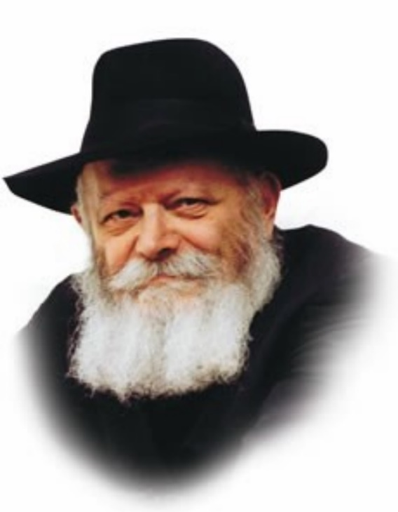

This week's Torah portion, Bo, discusses the Jews' spiritual preparations for the exodus from Egypt. When G-d decided to take the Jewish people out of Egypt, He saw that they were bereft of mitzvot. There was not one mitzva in whose merit they were worthy of being redeemed!

What did G-d do? He gave them two commandments with which to prepare themselves before the exodus: the blood of the Pascal sacrifice (the Jewish people were commanded to slaughter the Passover offering and put its blood on the door posts and lintels of their homes), and the blood of brit mila (the commandment to circumcise themselves on the night of the exodus from Egypt). It was in the merit of these two mitzvot that the Jews were redeemed.

These particular commandments were chosen by G-d because they represent the two dimensions of our Divine service: "depart from evil" and "do good."

"Depart from evil" means that we must rid ourselves of negative character traits and refrain from committing transgressions. "Do good" means that we must strive to strengthen our positive character traits and increase our performance of good deeds.

The Jewish people's G-dly service in Egypt was defective on both counts, both in the sphere of "departing from evil" and "doing good." The Jews did not sufficiently distance themselves from wrongdoing, due to the negative influence of the Egyptian environment. Nor did they engage in doing mitzvot or performing acts of goodness.

**A Need to Correct One’s Behavior in Both Directions**

Thus, in order to be redeemed, they had to correct their behavior in both directions.

"Depart from evil": The blood of the Pascal sacrifice signified the Jews' unequivocal dissociation from the evil of their surroundings. The Egyptians were idolators, and the lamb was one of their primary deities. Yet the Jews were commanded to take this "deity" and sacrifice it to G-d! By doing so the Jewish people irrevocably cut themselves off from the Egyptians' depravity.

"Do good": By performing brit mila, the Jews entered into an eternal covenant with the Creator.

"Depart from evil" and "do good" are thus both components of the process of redemption from Egypt, as it states, "When you have brought forth the people out of Egypt, you shall serve G-d upon this mountain."

"Depart from evil" refers to the exodus from Egypt.

"Do good" refers to the Jewish people's acceptance of the Torah at Mount Sinai.

By avoiding evil and increasing our performance of good deeds, we too will merit to leave our present exile and be worthy of greeting our righteous Moshiach.

*Reprinted from Reprinted from the 5757/1997 Bo edition of L’Chaim Weekly, adapted from Likutei Sichot, volume 16.*

**Shtadlanim:**

**Moses Feuerstein (1916-2009)**

**By Leah Lightman**

[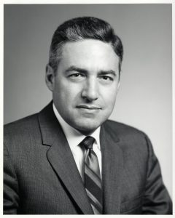](https://jewishaction.com/content/uploads/2021/11/Feuerstein1-scaled.jpg)

**Moses Feuerstein Courtesy of**

**Yeshiva University Archives**

The future for Orthodoxy Jewry looked bleak when Moses Feuerstein began his twelve-year tenure in 1954 as president of the Orthodox Union. World Jewry was still reeling from the Holocaust.

The non-Orthodox movements were strong and growing. The Orthodox day school movement was in its infancy, struggling to find students. On shaky ground, Orthodox Judaism questioned whether it would ever flourish in America.

**A Belief that Torah Must**

**Pervade All Areas of Life**

Undeterred and equipped with the belief that Torah must pervade all areas of life, Feuerstein spearheaded the planting of seeds that were ultimately responsible for the vibrant American Orthodox Jewish life we witness today.

As the late OU Honorary Past President Rabbi Joseph Karasick wrote upon Feuerstein’s passing: “By great fortune, Moses I. Feuerstein appeared on the scene and, knowingly or not, created a tsunami.”

**Founded the NCSY**

**Despite Opposition**

Under Feuerstein’s leadership, the OU founded NCSY, a youth movement that changed and continues to change the face of the American Orthodox landscape. Recalling the opposition Feuerstein and other lay leaders in support of NCSY faced, Bernard Lander, who went on to establish Touro College, wrote:

At the [OU] convention, the New York City delegates were skeptical [about the resolution to create such a movement], but the delegates from out of town were outspoken and enthusiastic. One by one they rose to tell of how badly they needed such an effort, of how Orthodox Judaism would not survive in their communities if it did not happen.

The OU’s new President Moses Feuerstein weighed in, as we knew he would, with his strong support, reminding the cynics that his father Samuel had faced similar criticism when he started Torah Umesorah a decade earlier.

**Succeeded in Bringing**

**About a Revolution**

By establishing this much-needed youth group, Feuerstein and other supporters succeeded in bringing about a revolution, transforming the lives of thousands of teens as well as entire families and communities. Similarly, during his tenure, he laid the groundwork for OU Kosher, enabling it to become the largest and most respected kosher certification agency, today certifying over one million products in more than 13,000 plants worldwide.

**Through Feuerstein’s vision and efforts, Orthodox Jews moved to the forefront of Jewish communal life, among other arenas. Statesman-like, Feuerstein led by example.**

Feuerstein strongly believed that rather than isolate themselves from the rest of the world, Orthodox Jews should reach out and build bridges and liaisons with other community organizations and leaders. His efforts resulted in the OU becoming active with other communal organizations such as the Conference of Presidents of Major American Jewish Organizations, the National Jewish Community Relations Advisory Council (now called the Jewish Council for Political Affairs), the Federation of Jewish Philanthropies (which later merged and became UJA-Federation of New York), local Jewish community councils and so many others.

**Helped OU Gain**

**Purpose and Meaning**

“Under his watch, the OU gained purpose and meaning, and Orthodoxy in America became a viable possibility when it hadn’t been for so many years,” Zev Eleff, an expert in the field of American Jewish history, wrote when Feuerstein passed away in 2009 at the age of ninety-three.

Through Feuerstein’s vision and efforts, Orthodox Jews moved to the forefront of Jewish communal life, among other arenas. Statesman-like, Feuerstein led by example, always publicly wearing his yarmulke at a time when this practice was uncommon.

Feuerstein was also able to relate to the diverse segments of the Orthodox world. As OU Honorary Vice President Michael Wimpfheimer recalls, “He was close to many of the gedolim at that time. He had a very strong connection to Rabbi Joseph B. Soloveitchik and he had close relationships with Rabbi Aharon Kotler and Rabbi Yaakov Kamenetsky.

[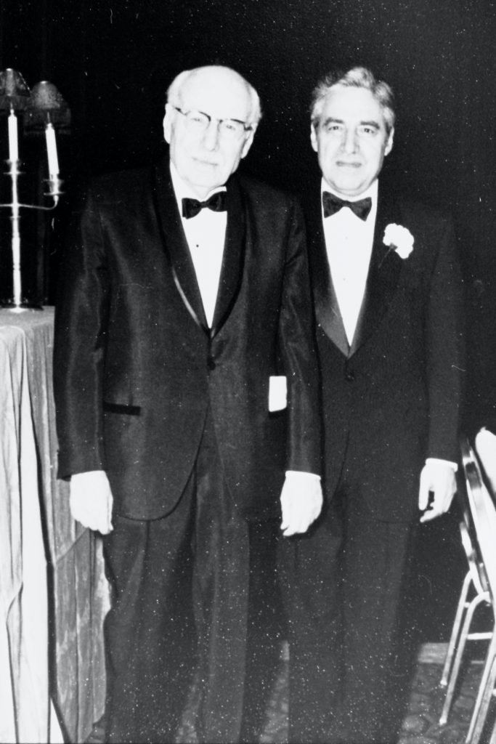](https://jewishaction.com/content/uploads/2021/11/Feuerstein2-scaled.jpg)

**Moses Feuerstein (right) with his father Sam Feuerstein at the 1989 RIETS dinner in Boston, where the family was honored. Courtesy of Yeshiva University Archives**

He was also active in Torah Umesorah. He had close friends in all circles of the Jewish world.” During Feuerstein’s administration, the Rav was appointed as the OU’s official posek, providing halachic guidance to OU leadership on a range of complex social and political issues.

In a tribute to Feuerstein, Rabbi Karasick recalled that “when the Roman Catholic Church’s Vatican II reversed longstanding anti-Semitic teachings, there was a big push for interfaith dialogue.

But the Rav felt strongly that discussion between Christians and Jews should be limited to nonreligious subjects, and Moe and the Orthodox Union followed the Rav’s directive.”

**Son of the Founder**

**Of Torah Umesorah**

Feuerstein’s leadership training commenced as a child in Boston. He learned firsthand about klal work from his father Samuel, a textile industrialist who served in a number of Jewish leadership positions and was the founder of Torah Umesorah.

His commitments on the national Jewish scene notwithstanding, Feuerstein was intimately involved with Orthodox Jewish Boston. He and his wife Shirley, together with the extended Feuerstein family, were the backbones of the Young Israel of Brookline and supporters of the Rav in building Boston’s Maimonides School.

Many university students passing through Boston during that time period were welcomed into the Feuerstein home for Shabbat and Jewish holidays and Feuerstein made

himself available to speak with those who sought his advice.

“[The Feuerstein home] was a home away from home for hundreds upon hundreds of college students who attended the renowned academic institutions in the area,” wrote OU Honorary Past President Rabbi Julius Berman.

A graduate student in Boston in the early 1970s, Chaya Levine remembers exploring the idea of launching a chesed project on college campuses. “There was no doubt in my mind that Moses Feuerstein would be the best person to discuss the details of what we were trying to do,” she says. “His understanding of the Jewish world, his focus and attention to detail remain an inspiration to me today.”

After being re-elected to his third term as OU president, he traveled throughout North America trying to fortify Orthodox communities, large and small, strengthen mechitzot in Orthodox shuls, and engage in dialogue with the spectrum of Orthodox Jewry in order to inspire and bolster their growth.

“He viewed himself as a spokesman for Yiddishkeit,” says Wimpfheimer.

*Reprinted from the Winter 2021 edition of the Jewish Action.* Leah R. Lightman is a freelance writer living in Lawrence, New York, with her family.

**Burst of Inspiration**

**Making Decisions**

**By Rabbi Ben Tzion Shaffier**

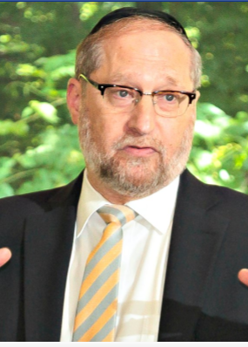

Sometimes when it comes to making decisions, we can be overwhelmed. Oh my goodness, I have to decide should I undergo this medical procedure or not. Should I expand my business or not? Should I take this job or not? What do I do with my children? And many times, the decision-making process becomes very anxiety-causing.

I’d like to share with you an observation that I think will make every decision in your life much easier. You’re not responsible to make the right decision. You’re responsible to make the best decision you can. You see, Hashem runs the world. What Hashem expects from you is to go out there and use your wisdom, use your understanding, ask advice, and reach the best possible conclusion that you can.



You’re responsible to go out there and try to make the best decision you can. Making the right decision — that’s up to Hashem. You’re going to make the best decision you can, because that’s the way Hashem wants you to use this world. Once you make that decision you take your heavy load, you put it on Hashem and you say Hashem, You created the world, You run the world. You’ve asked me to use this world in a certain way. I rely on You and trust in You.

The reason why we become overwhelmed is because we feel responsible to make the right decision. We human beings don’t know. Our job is to use our wisdom, use our understanding, reach the best conclusion we can, and then we understand that Hashem will determine exactly what will be. Our job is not to make the right decision; our job is to make the best decision we can.

*Reprinted from this week’s website of The Shmuz.com*